WORKSHEET – Do I have the right people in my team?
Instructions
1. Consider each of your direct reports, rathe their adherence to company values/behaviours and their general fit with the company culture on a 0-10 scale (Vertical Axis)
2. Consider each of your direct reports, rate their performance/productivity on a 0-10 scale (Horizontal Axis)
3. Mark an ‘X’ where the person sits on the scale and mark their initials
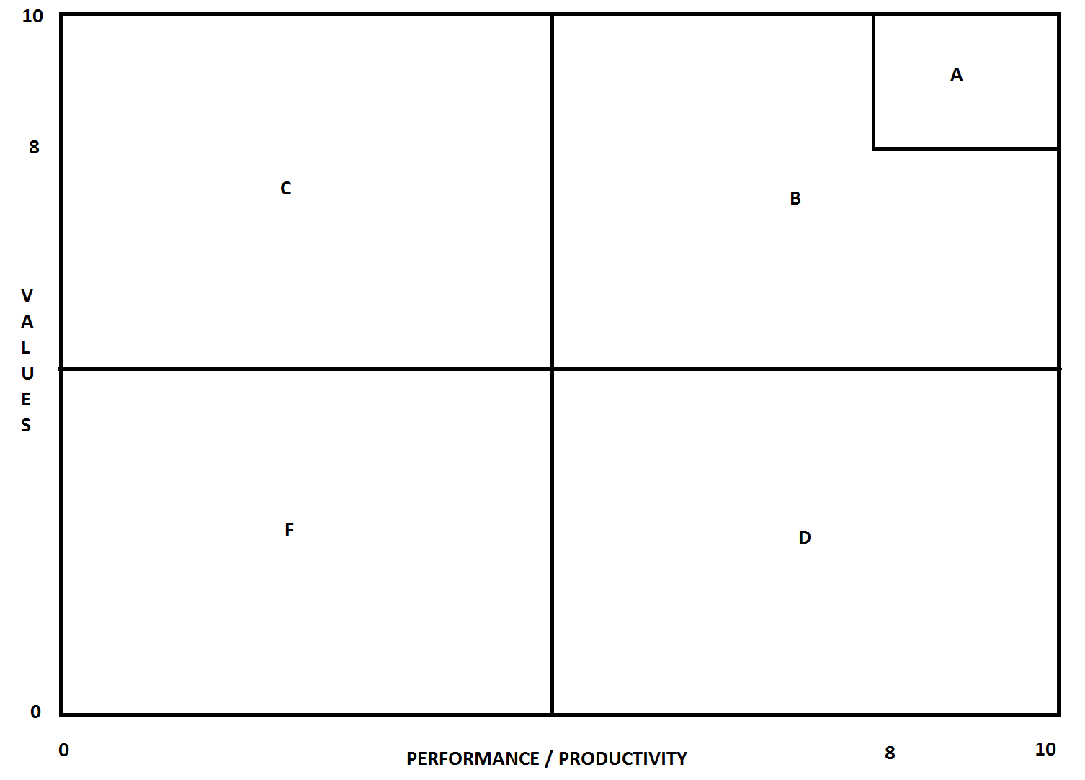
Questions to ask yourself
1. Are their any external influences on why their values/performance is at its current level?
2. Have you explained to your team members what 10/10 performance looks like?
3. Have you spoken to your team to explain where they sit and what the ‘gap’ is and what needs to be done to close this gap to achieve 10/10 performance?
4. Knowing what you know now, would you enthusiastically re-hire all of your team members?
5. What skills do you need to improve as a leader to help your team in achieving 10/10 performance?

